Net//Work Open Evening Group Discussion

Lizzie
Hello to anyone who's just joined us! Uma, Danielle and Leyya are joining us here for a chat, feel free to post any questions or comments!
We're working across a few time zones - @LEYYA (she/her) , @Iarchivethosewhowerelost and @Uma (they/them) where are you all 'calling' in from today?

LEYYA (she/her)
Oakland Californiahhhhh

Iarchivethosewhowerelost
hiiiiiiiiiiiiiiiiiiiiiiiiiiiiiii
berlin time

Uma (they/them)
gateshead here

LEYYA (she/her)
lets continue deciphering Danielle's key - did we figure out 1836MJ?

Lizzie
I'm still searching!

LEYYA (she/her)
me too!

Iarchivethosewhowerelost
hhhaahah

LEYYA (she/her)
(thats a suspicious laugh!)

Iarchivethosewhowerelost
we should share influences

Uma (they/them)
sorry, went for toast and to feed dog

@Uma (they/them)
sorry, went for toast and to feed dog
Lizzie
aww, hope the dog is now contentedly fed!

Uma (they/them)
yeah hes going back to sleep. his days work done

@Uma (they/them)
sorry, went for toast and to feed dog
LEYYA (she/her)
nice! I'm gonna need a disco nap this afternoon too!

Uma (they/them)
influences, i think i talked a bit about this. very much been shaped by our conversations, but also this game World of Horror which ive mentioned before

LEYYA (she/her)
influences - honestly (and uma said it earlier) - my biggest influence came from our residency conversations and deep dives into the work of Uma, Danielle, and Nikissi too!

Uma (they/them)
its so good. uses lots of random generated events, and plays with the interface being both in and outside of the game. like, when you click on some things you are acting as the character not just the player.

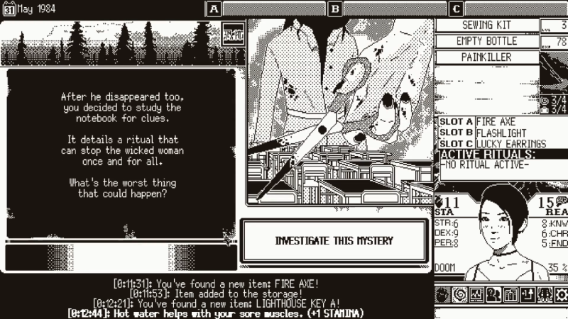

Uma (they/them)
its so good. uses lots of random generated events, and plays with the interface being both in and outside of the game. like, when you click on some things you are acting as the character not just the player.

Uma (they/them)
also watched the film One Cut of The Dead which just blew my mind in the same kind of way

LEYYA (she/her)
What really kinda broke things open for me was looking at ARG models and thinking about existing structures as a tool

Lucy
Sorry - I was just off catching up with Uma's game! I was going to ask if being part of the residency together had influenced your ways of working ...but you pretty much answered it there!

Uma (they/them)
Id like to know what other stuff you two have been looking at, both things that are like "yes, i was definitely influenced by that" and things that are more tangental

LEYYA (she/her)
totally... incoming ....

Iarchivethosewhowerelost
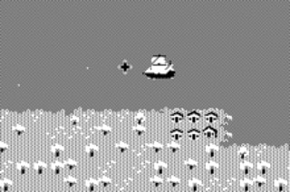

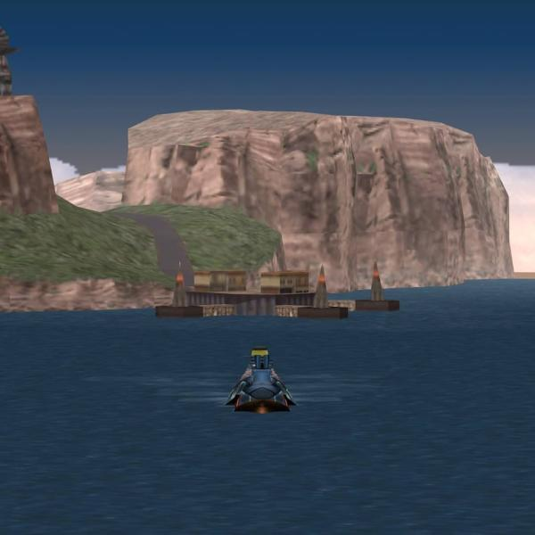
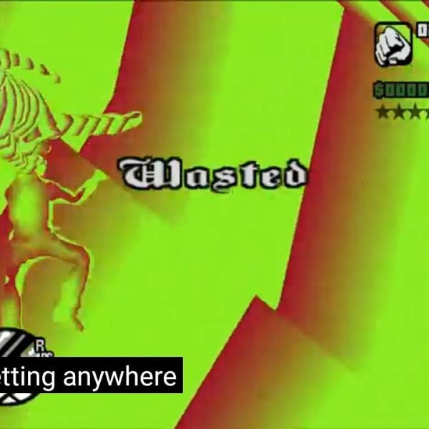
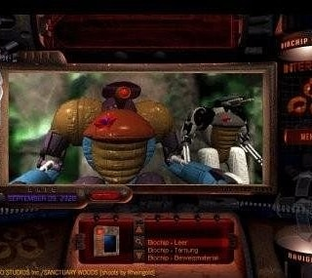
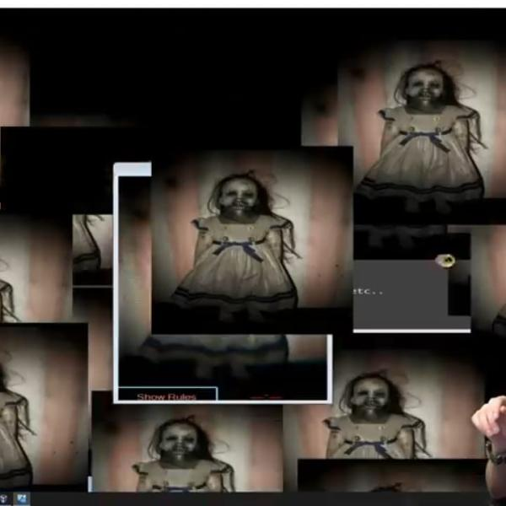

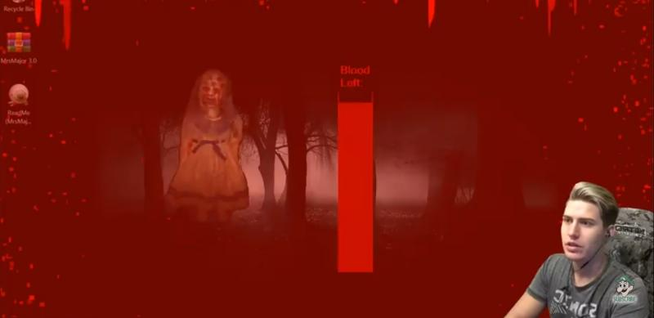
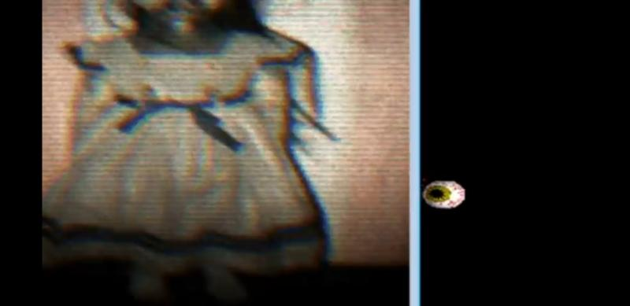
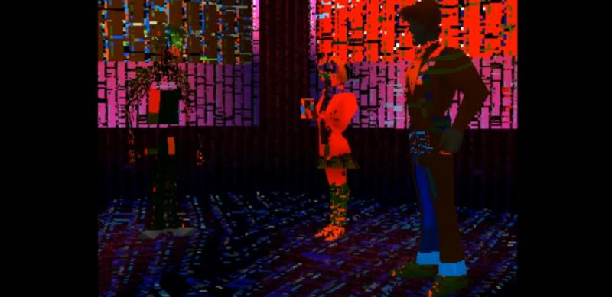
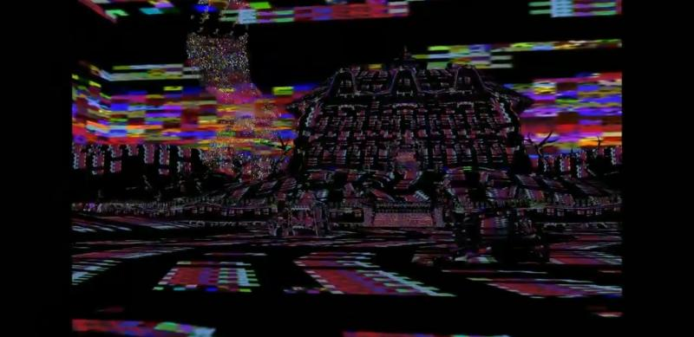
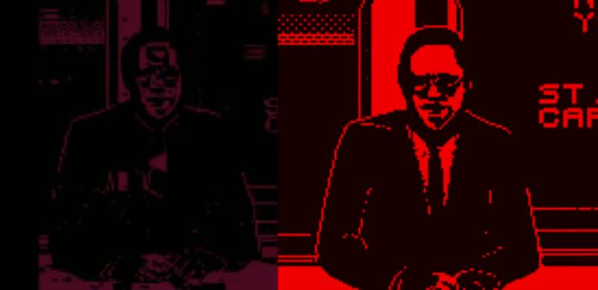
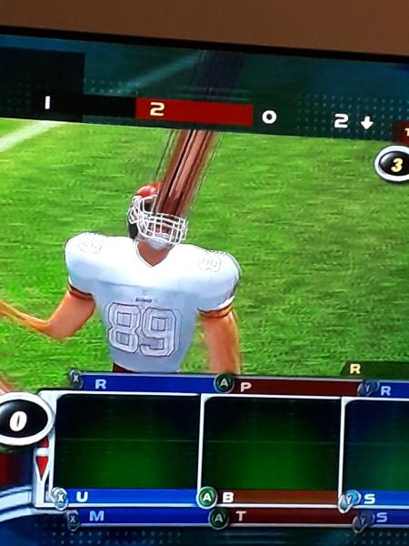

Influencesssss

@LEYYA (she/her)
What really kinda broke things open for me was looking at ARG models and thinking about existing structures as a tool

Lizzie
I was about to mention this! That was a great conversation. For anyone not familiar with ARGs: https://en.wikipedia.org/wiki/Alternate_reality_game (I am sure there are better explainers than wiki though!)
Alternate reality game
An alternate reality game (ARG) is an interactive networked narrative that uses the real world as a platform and employs transmedia storytelling to deliver a story that may be altered by players' ideas or actions. The form is defined by intense player involvement with a story that takes place in real time and evolves according to players' respon...

LEYYA (she/her)
DANIELLE!!!! for the win

Iarchivethosewhowerelost
YES I THINK ME AND LEYYA FELL IN LOVE WITH ARGS

Uma (they/them)
i find them terrifying!

LEYYA (she/her)
this is one of my favorite web-audio projects http://www.hellochar.com/flame?name=Lime
Xiaohan Zhang - Interactive Art, Generative Design, Emergent Systems
Interactive media works of Xiaohan Zhang.

@Uma (they/them)
i find them terrifying!
LEYYA (she/her)
terrifying queer horror??

@LEYYA (she/her)
terrifying queer horror??
Uma (they/them)
the scale of ARGs, like the idea of making something so interconnected makes me dizzy

@LEYYA (she/her)
this is one of my favorite web-audio projects http://www.hellochar.com/flame?name=Lime
Uma (they/them)
this is really nice.

Iarchivethosewhowerelost
They make think of the film tenet
how to present a non linaer artwork

LEYYA (she/her)
also a huge fan of Raed Yassin - who is like a real life ARG, working in music, remix, taxidermy opera, cooking shows, and photo-fiction

Lizzie
taxidermy opera sounds amazing

@Lizzie
taxidermy opera sounds amazing
LEYYA (she/her)
looking for link

Uma (they/them)
can I ask one of my questions now?

Iarchivethosewhowerelost
Yes

LEYYA (she/her)
also a huge fan of Raed Yassin - who is like a real life ARG, working in music, remix, taxidermy opera, cooking shows, and photo-fiction

LEYYA (she/her)
https://www.onassis.org/whats-on/sea-between-my-soul

@LEYYA (she/her)
https://www.onassis.org/whats-on/sea-between-my-soul
Lizzie
this looks incredible!

Lucy
wow - thanks for sharing all these great inspirations!

Uma (they/them)
so Danielle, I wanted to ask about like workflow and the process of making stuff. I noticed how you change up your engines, languages, form of work and so on frequently, while always focusing on this process of the archive. So does the tools your working with have a big impact on how you work? like we talk about this all the time with artists that work in more physical mediums

@Lucy
wow - thanks for sharing all these great inspirations!
Chloe (Wysing)
yes, thank you all so much!

Uma (they/them)
same goes for the workshopping/interviewing/collaborating bit of your practice
short version: whats different for you about Scratch from Unity?

Iarchivethosewhowerelost
yes. i change engines and language and mdium based on what the work needs. i dont believe that the sma eway of archiving can work for all things so you need to redo the entire structure everytime you make an archive
so i always start at square 1
scratch is fast unity is huge and hard

@Iarchivethosewhowerelost
scratch is fast unity is huge and hard
LEYYA (she/her)
thats pretty much true even if you don't know anyting about programming

Iarchivethosewhowerelost
so the tools never are chosen before i start

Uma (they/them)
do you feel you produce different kinds of work under those different conditions? like something quick vs something slow? something you see what you are making straight away vs someone you only really see after a 12 hour render?(edited)

Iarchivethosewhowerelost
hahha
yes its the same process with poly models. you get somethign else out when you work quicker
comeplared to slower methodical thinking
both are importatn
so its about mixing the two
layya can i ask what draws you to want people to put of themslves into your work?

LEYYA (she/her)
I love when Uma and Danielle get into it... I hold on for dear life and always learn something about my own world!

Lucy
really like that, that even if something is quicker to create, that it can still be a work in it's own right, rather than a 'sketch' of something - it has a different purpose

@Iarchivethosewhowerelost
layya can i ask what draws you to want people to put of themslves into your work?
LEYYA (she/her)
ah yeah.. thats everyting and also i feel myself handsfree of it... i will elaborate
I want to demand presence from the audience, have them accept their role in the transmission of the work, either as gift or burden or refusal or delight. But as you said earlier - not passive!

Lucy
oohh good questions! I was also going to ask if any of you ever find out what people put into your work - do you want to hear what reactions or inputs people are having into your work, or is it just important that they interact in some way (even if not how you intended)?

@LEYYA (she/her)
I love when Uma and Danielle get into it... I hold on for dear life and always learn something about my own world!
Uma (they/them)
lol, I have zero self awareness and just rabbit when I'm excited about stuff

LEYYA (she/her)
but as well - i'm interested in the ummmm.... not indifference... but the invulnerability of the work too.
Like - the integrity of the score, the statement, the thing - is as intended, even if the intention is to destroy itself, or modulate, or to give up controls, etc

Iarchivethosewhowerelost
like it self automates?

@Lucy
oohh good questions! I was also going to ask if any of you ever find out what people put into your work - do you want to hear what reactions or inputs people are having into your work, or is it just important that they interact in some way (even if not how you intended)?
LEYYA (she/her)
I was wondering this about Uma and Danielle's too. With Malayeen - I gather the input if the user agrees to an email exchange. Then I can see their variables

@Iarchivethosewhowerelost
like it self automates?
LEYYA (she/her)
yes! Totally.
In the self automation - the ego is put to less use

John Bloomfield
What will you do with the archive you collect Leyya?

@John Bloomfield
What will you do with the archive you collect Leyya?
LEYYA (she/her)
million bitcoin question

Lucy
That totally makes sense - like a way of putting something out there but then letting it go in some way

@Lucy
That totally makes sense - like a way of putting something out there but then letting it go in some way
Lizzie
yes and that reflects the nature of collected songs and music passed on from person to person.. they change over time

Iarchivethosewhowerelost
i dont cllect anything but i want to

LEYYA (she/her)
I want to see what is collected first (not public) - and allow the accumulation of songs to tell me what it needs... should it be a library mapped in time/location? Will it speak of one region more than others? Will it result in direct collaboration?

Iarchivethosewhowerelost
because you cab assess their choices

LEYYA (she/her)
Exactly... and see what the collection says. It will become its own conversation i think

Lucy
That could be so interesting @Iarchivethosewhowerelost almost mapping where people are coming from too

@LEYYA (she/her)
I want to see what is collected first (not public) - and allow the accumulation of songs to tell me what it needs... should it be a library mapped in time/location? Will it speak of one region more than others? Will it result in direct collaboration?
John Bloomfield
That makes sense

Richard_Davis
Sorry for just jumping in here (currently travelling home on train and dipping in and out of the chat). But earlier Uma mentioned using Scratch vs Unity. I have no experience of using these kind of platforms to create work, but vaguely knowing Unity and what it can offer, I wanted to ask about the choice style that I see in @Uma (they/them) and @Iarchivethosewhowerelost ‘s work. Is it a conscious choice to have a more retro graphic look, or is it because of the platforms you use?

LEYYA (she/her)
There are origin stories in all three of our works - and also natural elements for navigation

@Lucy
That could be so interesting @Iarchivethosewhowerelost almost mapping where people are coming from too
Iarchivethosewhowerelost
or like challenging them on what thei choices mean

LEYYA (she/her)
@Uma (they/them) - Earth, @Iarchivethosewhowerelost - Sea, and Malayeen.....
Question for @Uma (they/them) ~ there is so much sensory information and direction in your work.....
Smell, Sound, Weight....

@Iarchivethosewhowerelost
or like challenging them on what thei choices mean
Lucy
that could be so powerful!

LEYYA (she/her)
Do you have a physical practice that informs your decisions?

LEYYA (she/her)
@Uma (they/them)

@Iarchivethosewhowerelost
i dont cllect anything but i want to
Uma (they/them)
yeah, from looking at Leyya's work I really wanted to do this, like you answer questions in the game and then you can like get a simple txt file downloaded based on what you inputted, or just like a screenshot button would be good

@Uma (they/them)
yeah, from looking at Leyya's work I really wanted to do this, like you answer questions in the game and then you can like get a simple txt file downloaded based on what you inputted, or just like a screenshot button would be good
LEYYA (she/her)
its cool cuz i get something - and the audience/participant gets a .wav gift in return!

Iarchivethosewhowerelost
why does the audience deserve that gift?

@Iarchivethosewhowerelost
why does the audience deserve that gift?
LEYYA (she/her)
ak! good question. damn.

@LEYYA (she/her)
its cool cuz i get something - and the audience/participant gets a .wav gift in return!
Bekky, British Council
the beauty of exchange?

@Richard_Davis
Sorry for just jumping in here (currently travelling home on train and dipping in and out of the chat). But earlier Uma mentioned using Scratch vs Unity. I have no experience of using these kind of platforms to create work, but vaguely knowing Unity and what it can offer, I wanted to ask about the choice style that I see in @Uma (they/them) and @Iarchivethosewhowerelost ‘s work. Is it a conscious choice to have a more retro graphic look, or is it because of the platforms you use?
Uma (they/them)
same as Danielle I like the speed of some things, but I have a really strong positive of negative relationship to software, some things immediately gel , and some I really struggle to get into a flow. I have really good flow with Aseprite (the prog i make the images in mostly) and thats quite limited, so game is to a degree based around that

@LEYYA (she/her)
@Uma (they/them) - Earth, @Iarchivethosewhowerelost - Sea, and Malayeen.....
Uma (they/them)
YES!!

@Iarchivethosewhowerelost
why does the audience deserve that gift?
LEYYA (she/her)
i think, for this project, I am making up for all the live shows that I just inundate the room with my bizness.... impervious to the peoples. Out of time/place.

Iarchivethosewhowerelost
rerto aesthetics hold histor y and when you play with that history it can really make the work claim its space in time

@Bekky, British Council
the beauty of exchange?
LEYYA (she/her)
exactly. and its not an anonymous exchange - but its also kinda ethereal.... imaginary

@LEYYA (she/her)
Do you have a physical practice that informs your decisions?
Uma (they/them)
Yeah sensory stuff is my main thing really, I trained as a sculptor, and then as an SEN art teacher and playworker, and horror is a very sensory genre, also the feminist theory that I mostly read is about that, things beyond language

@Iarchivethosewhowerelost
rerto aesthetics hold histor y and when you play with that history it can really make the work claim its space in time
LEYYA (she/her)
I'm going to cut/paste that for my next artist statement. jus sayin

Bekky, British Council
I personal feel that exchange is perhaps the foundation of any interaction
acknowledged or not

@Bekky, British Council
acknowledged or not
LEYYA (she/her)
very true. its embedded.

Iarchivethosewhowerelost
sometimes it is not concious

Uma (they/them)
yeah to exchange. i think thats what i was getting at asking about using different engines and stuff, like the push-pull of working with a system

@Uma (they/them)
Yeah sensory stuff is my main thing really, I trained as a sculptor, and then as an SEN art teacher and playworker, and horror is a very sensory genre, also the feminist theory that I mostly read is about that, things beyond language
LEYYA (she/her)
wondering if you have a ritual practice (in movement or song or meditation) that grounds your practice - "grounds" being specific -
like earth, birds, smell....

@LEYYA (she/her)
wondering if you have a ritual practice (in movement or song or meditation) that grounds your practice - "grounds" being specific -
Uma (they/them)
ahhh, yeah, so in another life I was in a performance collective that mostly worked with rituals

Uma (they/them)
ahhh, yeah, so in another life I was in a performance collective that mostly worked with rituals

Uma (they/them)
http://aasgroup.net/event/lammas-drone-silo/

Lizzie
ah Uma thanks for sharing this!

LEYYA (she/her)
And actually - similarly to @Iarchivethosewhowerelost - what is the sea to you... in your body, in your hands as you type? Because your work is so TANGIBLE

@Uma (they/them)
http://aasgroup.net/event/lammas-drone-silo/
LEYYA (she/her)
beautiful

Lizzie
shall we continue the conversation at #leyya-mona-tawil 's channel?

LEYYA (she/her)
Race ya there!

@LEYYA (she/her)
And actually - similarly to @Iarchivethosewhowerelost - what is the sea to you... in your body, in your hands as you type? Because your work is so TANGIBLE
Iarchivethosewhowerelost
the body holds memoriess just the oceandoes. the bends the dents the rise and fall of waves are all historical

LEYYA (she/her)
yes it does....

